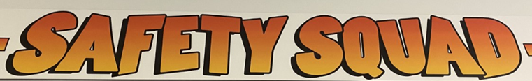

Dear Abbots Green pupils
Safety Squad have a new mascot – Nemo! We would like you to come up with a mnemonic to link this character to our work on keeping safe in school.

Watch this video to learn about mnemonics:
https://www.youtube.com/watch?v=AcUoW1ek5zU&t=68s

Can you think of one that links ‘Nemo’ to our safety squad in school?
Example:
Now
Everyone
Must
Observe

We look forward to seeing yours!
From Mrs Uttley & The Safety Squad

