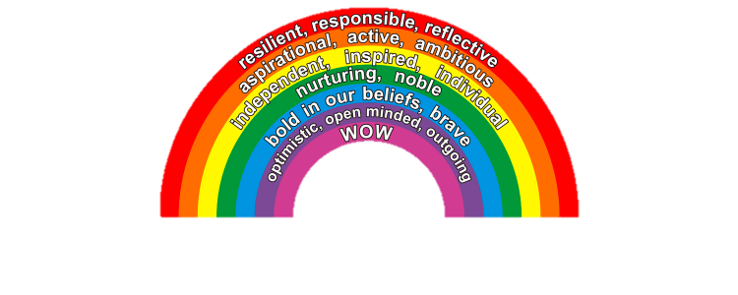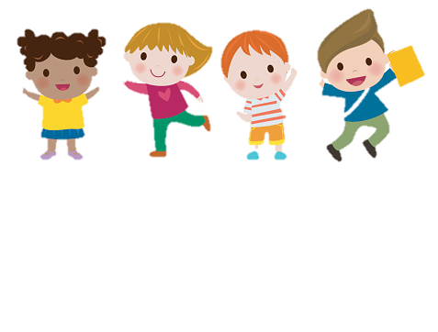



**Transition Workbook**

**Coming back into school**





**Coming into school can be exciting for most children - meeting and seeing their friends. However, for some children, especially with the circumstances of the closure, this may cause some concerns and worries. The transition can be difficult. At Abbots Green, we recognise that any transition in a child’s life is important therefore, we would like to make this as smooth as possible. This personalised visual booklet will support your child in understanding their transition visually with the aim to make them feel more secure and less worried. More importantly, this will indicate to us how we can support your child in the best possible way.**

**Kind Regards**

**Mrs Arfi, Mrs Uttley and Mrs Miles**





**All about me!**

**My name is …………………………**

**I am …………………….years old**

**I am in …………………………Class**

**This is me!**



**My favourite things to do are:**

**Draw them in the spaces below.**





**These are my friends:**

**Draw them here**



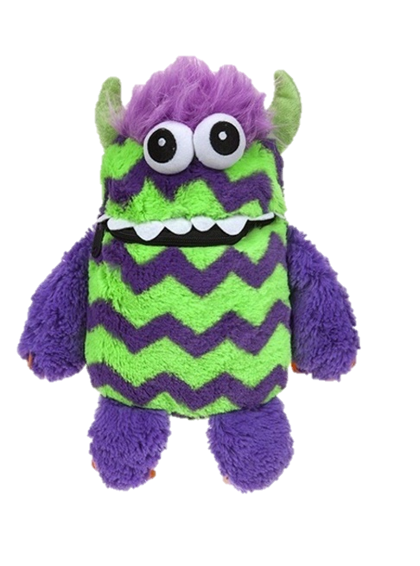

**My worries about coming into school**



**What would help my worries go away?**





**Who would you like to help you with your worries?**





**Dear Parents/Carers**

**Please write your thoughts and comments below.**



**Dear ……………………………..**

**Thank you for sharing your worries.**

**If…**

**Then…**

