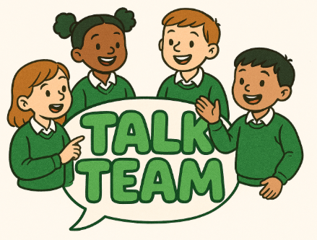

What to expect at a Talk Team meeting:

* Represent your class
* Share your ideas linked to an agenda
* Listen to your fellow members
* Be democratic and take part in voting
* Respectfully add to discussions
* Be prepared to attend meetings during lunch time
* To write minutes
* To take important information back to class
* Come prepared!